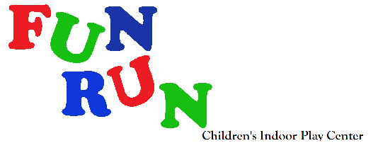 School ____________ Date_____
In Consideration of being allowed to enter the play area and/or participate in any party and/or program at Kidz Playground, LLC DBA Fun Run the undersigned, on his or her behalf, and on the behalf of the participant(s) identified below, acknowledge, appreciates and agrees to the following conditions:

I represent that I am the parent or legal guardian of the participant(s) named below, or I have obtained permission from the parent/legal guardian of the participant(s) named below to execute this agreement on their behalf, I agree that the participant(s) named below and I shall comply with all stated and customary terms posted safety signs, rules, and verbal instructions as conditions for participation in any party and /or program at Kidz Playground, LLC DBA Fun Run. In addition, if observe any hazard during our participation, I will bring it to the attention of the nearest Kidz Playground, LLC DBA Fun Run employee or official immediately.

I am aware that there are inherent risks associated with participation in Kidz Playground, LLC DBA Fun Run programs, parties, and/or use of the play area and inflatable equipment and I, on behalf of myself and the participant(s) named below, knowingly and freely assume all such risk, both known and unknown, including those that may arise out of the negligence f other participant(s) and,

I, for myself and the participant(s) named below, and our respective heirs, assigns, administrators, personal representatives, and next of kin, herby release and hold harmless, Kidz Playground, LLC DBA Fun Run, their affiliates, officers, members, agents, employees, other participant(s), and sponsoring agencies from and against any and all claims, injuries, liabilities or damages arising out of or related to our participation in any and all Kidz Playground, LLC DBA Fun Run programs, activates, parties, the use of the play area and/or inflatable equipment. I, for myself and the participant(s) named below, we have read and understand the posted rules.

SOCKS ARE REQUIRED FOR CHILD TO BE ABLE TO PLAY IN FACILITY. PLEASE WEAR OR BRING SOCKS!

Guardian Signature Date: Child’s Name Emergency Phone Contact

______________________________________________________________________________________________

____________________________________________________________________________________________________________

____________________________________________________________________________________________________________

____________________________________________________________________________________________________________

____________________________________________________________________________________________________________

____________________________________________________________________________________________________________

____________________________________________________________________________________________________________

____________________________________________________________________________________________________________

____________________________________________________________________________________________________________

____________________________________________________________________________________________________________

____________________________________________________________________________________________________________

____________________________________________________________________________________________________________

____________________________________________________________________________________________________________

____________________________________________________________________________________________________________

____________________________________________________________________________________________________________

____________________________________________________________________________________________________________

____________________________________________________________________________________________________________

____________________________________________________________________________________________________________

____________________________________________________________________________________________________________

